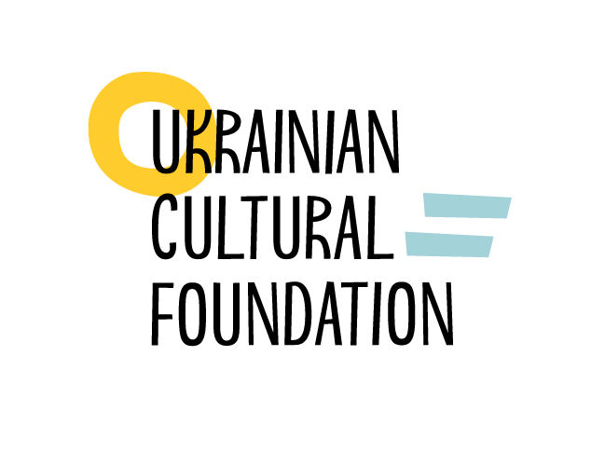  Application for funding  from the Ukrainian Cultural Foundation |  |  |  | Guidelines for applicants:  1. Complete the application form in Word.  2. Make a high-quality printout.  3. Put the date and your signature.  4. Scan it into a pdf. file.  5. Submit the e-version via Personal Account at ucf.in.ua, and send the original copy to  01010 Kyiv, Lavrska Str. 10-12.  Application DDL: 02.07.2018, 6pm.
Section I: Project profile
Priority (please, select one priority) |  | supporting cultural projects at the stages of conceptualization, preparation and pre-production thereof  facilitating analysis and research in culture and arts  facilitating introduction of innovations, digital technologies and digitalization in culture and arts  supporting young creative persons and cultural and art debuts, as well as facilitating professional growth of talented children and youth  facilitating inclusion in culture and arts, expanding audience through engaging various age and social groups  ensuring cross-sectoral cooperation and establishing inter-regional cultural dialogue to support development of communities, creative development of small territories of Ukraine  engaging international partners in implementation of joint initiatives and co-funding of cultural projects, including those supported within the framework of the Creative Europe programme or other EU programmes  facilitating presentation of the Ukrainian culture and arts abroad, including at international events and exhibitions  facilitating development of an e-resource on cultural heritage and cultural values, and facilitating introduction of modern information technologies in museum and cultural heritage management  facilitating development of educational initiatives in the fields of culture and arts, including in creative industries, aimed to support education, training and retraining in the field of arts  ensuring comprehensive development and functioning of the Ukrainian language in all aspects of social life throughout the whole territory of Ukraine  facilitating preservation of cultural diversity, respect of peculiarities of other cultures at local, national and international levels
Type of contest (please, select one type) |  | contest of individual projects  contest of national cooperation projects  contest of international cooperation projects
Project name
Brief description of projects (up to 100 words)
Sector of culture and arts  (please, select one sector) |  | visual art  audial art  audiovisual art  design and fashion  performing art  cultural heritage  literature and publishing  cultural and creative industries
Overall project budget (UAH)
Amount applied for to the Ukrainian Cultural Foundation (UAH)
Project implementation period |  | Start date |  |  | End date

Part II: Information about the project coordinator
Surname, name and patronymic
Contacts | Email |  | Telephone
Position

Section ІІІ: Information about the applicant
Name of organization | Full name |  |  | Short name
Surname, name and patronymic of head of organization
Contacts of head of organization | Email |  |  | Telephone
Form of business
USREOU code (ID number)
Registered office |  | Place of business |  |  | Postal address
Website
Main areas of activities
Available material and technical resources, and equipment for project implementation
Examples of the most successful projects
Previous grants

Section IV: Information about the partner organization
Name of organization | Full name |  |  | Short name
Surname, name and patronymic of head of partner organization
Contacts of head of organization | Email |  |  | Telephone
Form of business
USREOU code (ID number)
Registered office |  | Place of business |  |  | Postal address
Website
Main areas of activities
Available material and technical resources, and equipment for project implementation
Examples of the most successful projects
Previous grants

Section V: Information about the partnership(s)
Reasoning of the choice of the partner organization(s)

Why did you choose this(ese) partner(s) for the implementation of your project? Have you ever cooperated with this(ese) partner(s) before? How is the implemented project expected to influence the development of the applicant, partner(s) and the partnership in general?
Distribution of roles within the partnership

What is the scope of responsibility and the level of involvement of each partner within the partnership — both applicant and the partner(s)?

Section VI: Detail description of project
Project relevance

Why is the proposed project relevant for Ukraine in general and for a particular geographical region in particular? Why is the project important in the global context? Why is the project unique? Was the project fully or partially implemented before? In what way does the project complement the existing regional and national cultural policies? In what way does the project complement the existing cultural initiatives?
Purpose and objectives, expected results of the project

What are the project objectives? What results are expected to be achieved due to implementation of the project? What are the project short-term results? What are the project long-term results? In what way is achievement of project objectives assessed? Does the project have a monitoring and assessment plan? What performance indicators will be used for the assessment purposes?

Project team

Surname, name and patronymic of each member of the project team | Organization  (-applicant/-partner) | Role in the project | Relevant experience

Project work plan (including the preparation, implementation and reporting stages)

Activities  (key project stages) | Responsible person | Implementation terms (September, October, November)

Target audience

Who are the direct target audience of the project? Age and profession of the target audience, number of audience by age and profession? Who are the indirect target audience of the project? In what way those two types of target audience are expected to be involved?
Information support to the project

What will be the ways of disseminating information about the project? What information and media partners will participate in the project implementation? What mass media will be engaged for cooperation? What are the confirmed and planned partnerships? What new technologies and media will be used by the project for disseminating information?
Project risks

What risks (technical, financial, organizational, political, legal, construction, force majeure etc.) are associated with the project? What strategy will the project use to reduce those risks?
Project sustainability

What will be the post-project activities? In what way the organization is going to share experience with other organizations? Is the organization planning on networking the proposed project? Is the organization planning on establishing partnerships with other organizations beyond the project?

Declaration of integrity and signature of head of the applying organization
I, the undersigned, having read and understood the Regulation on holding a call for project proposals, the Guidelines for applicants in the Art Contest. International Cooperation Projects, understanding the rules of the competitive selection procedure and requirements to applicants, being motivated to provide complete and accurate information about the planned project, and realizing my responsibility for providing inaccurate data, kindly ask you to accept the project proposal of the applying organization competing for funding by the Ukrainian Cultural Foundation.

Surname, name and patronymic of head of applicant |  | Signature
Date

Appendix to the application  for funding from  the Ukrainian Cultural Foundation | Guidelines for applicants:  1. Complete the appendix form in Word.  2. Scan it into a pdf. file.  3. Attach it to the application.
In the appendix to the application, the applicant may provide any additional useful information about the project. For example, more detail information about the professional experience of the project coordinator, or deeper assessment of the artistic value of the project (up to 3 pages).

Project coordinator is a representative of applicant and a contact person for the Ukrainian Cultural Foundation in any daily matters. Where the applicant is a sole trader, project coordinator and head of the organization are the same person. See more information about project coordinator in the Guidelines for applicants.
See more information about applicants in the Guidelines for applicants.
If there are several partner organizations, please, fill in Section IV for each partner organization. See more information about partner organization in the Guidelines for applicants.
This appendix is not compulsory and must only be completed if appropriate.

